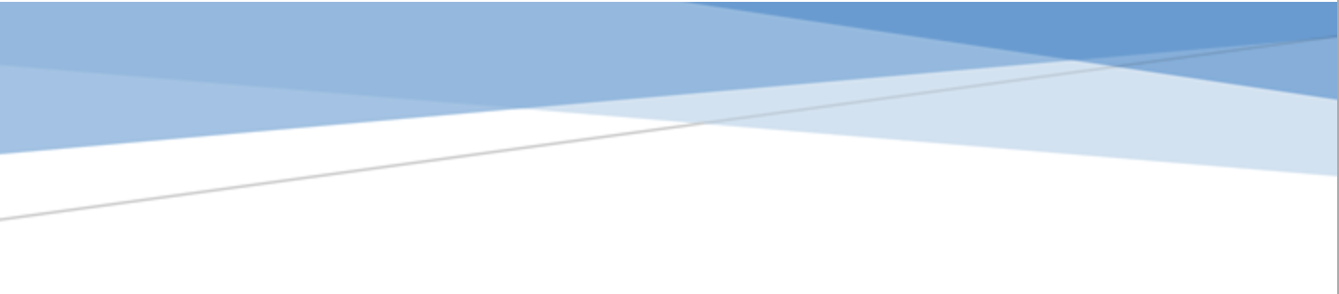



adges UI components library

**Component ID #1 – ex-layout - v1.0.0**

## Document Control

## Version History

|  |  |  |  |
| --- | --- | --- | --- |
| Version | Date | Author | Reason for Change |
| **1.0.0** | 10/13/2019 | Wael |  |
|  |  |  |  |
|  |  |  |  |
|  |  |  |  |
|  |  |  |  |
|  |  |  |  |
|  |  |  |  |
|  |  |  |  |

## Review History

|  |  |  |
| --- | --- | --- |
| Version | Reviewer | Date |
|  |  |  |
|  |  |  |
|  |  |  |
|  |  |  |
|  |  |  |
|  |  |  |
|  |  |  |

Table of Contents

Document Control 2

Version History 2

Review History 2

1. Document and components Purpose. 4
2. General Information. 4
3. How to use. 9
4. Component features and configure. 10
5. Modifiers 14
6. How to configure component. 14
7. Examples 15

# 

# Document and components Purpose.

The purpose of the document is to guide how use and configure [Dynamic Highlight] component.

The purpose of the dynamic highlight you can add any features or latest item on your site with image background or video and you can configure the component based on your branding guideline.

# General Information.

Component Name: Layout.

Extension Theme: ex-layout.

Owner: Wael.

Version no: v1.0.0

Design

**Typography**

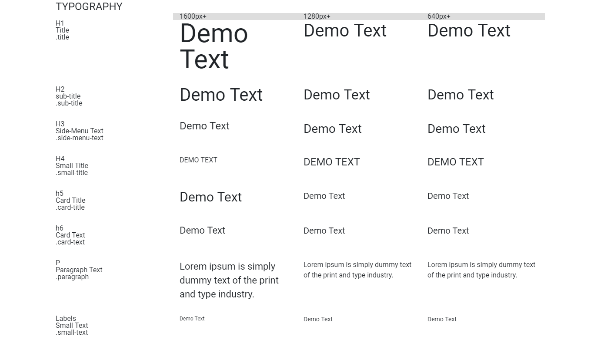

**Buttons Styles**

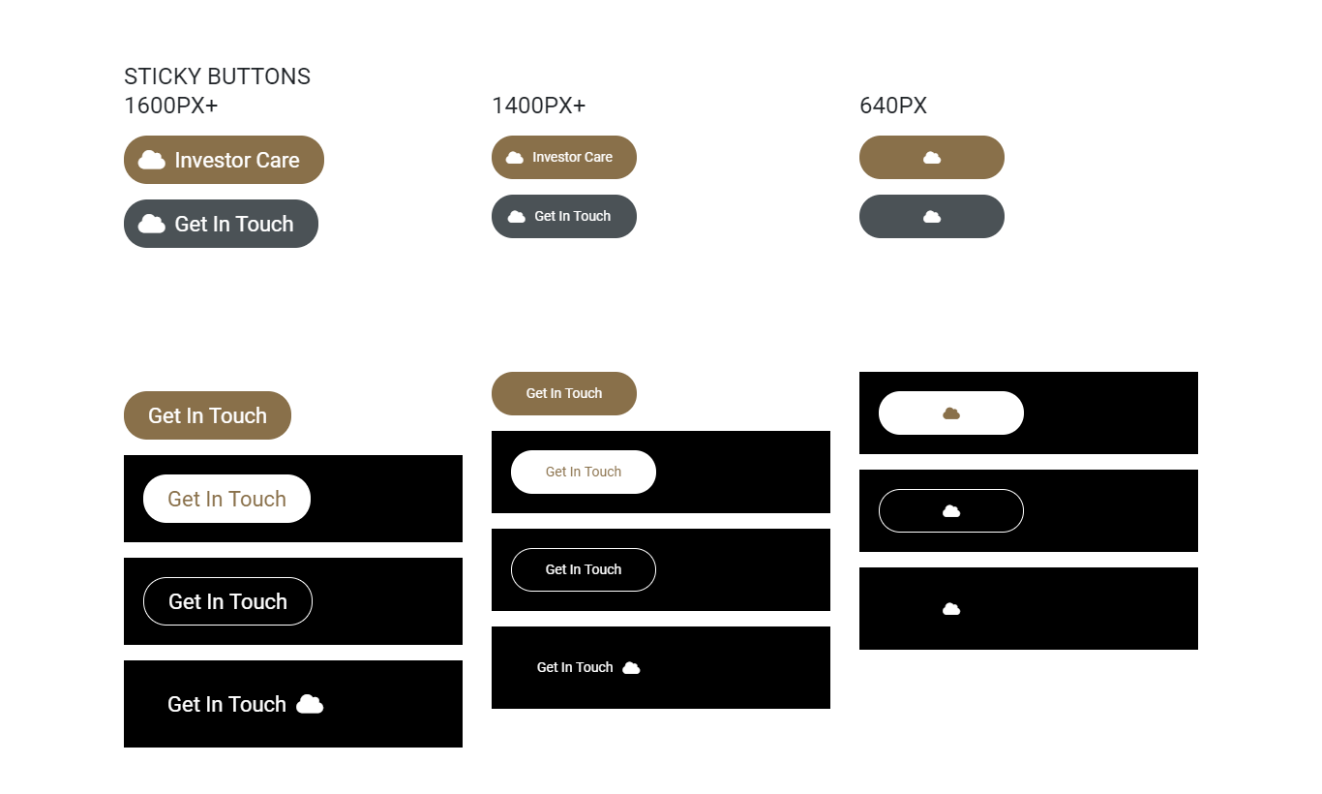

**Section Styles**

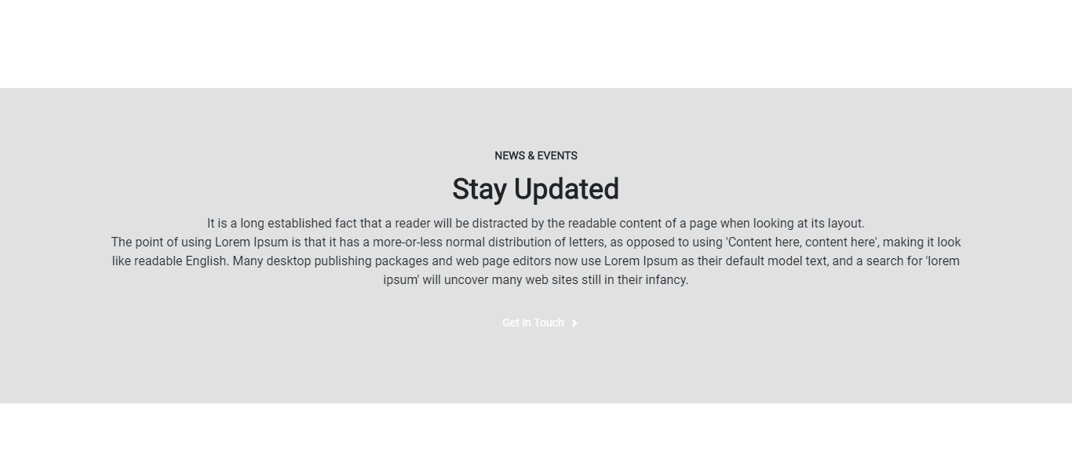

section--bg-effect style

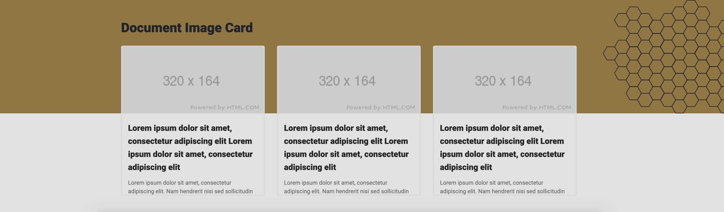

**Search Listing**

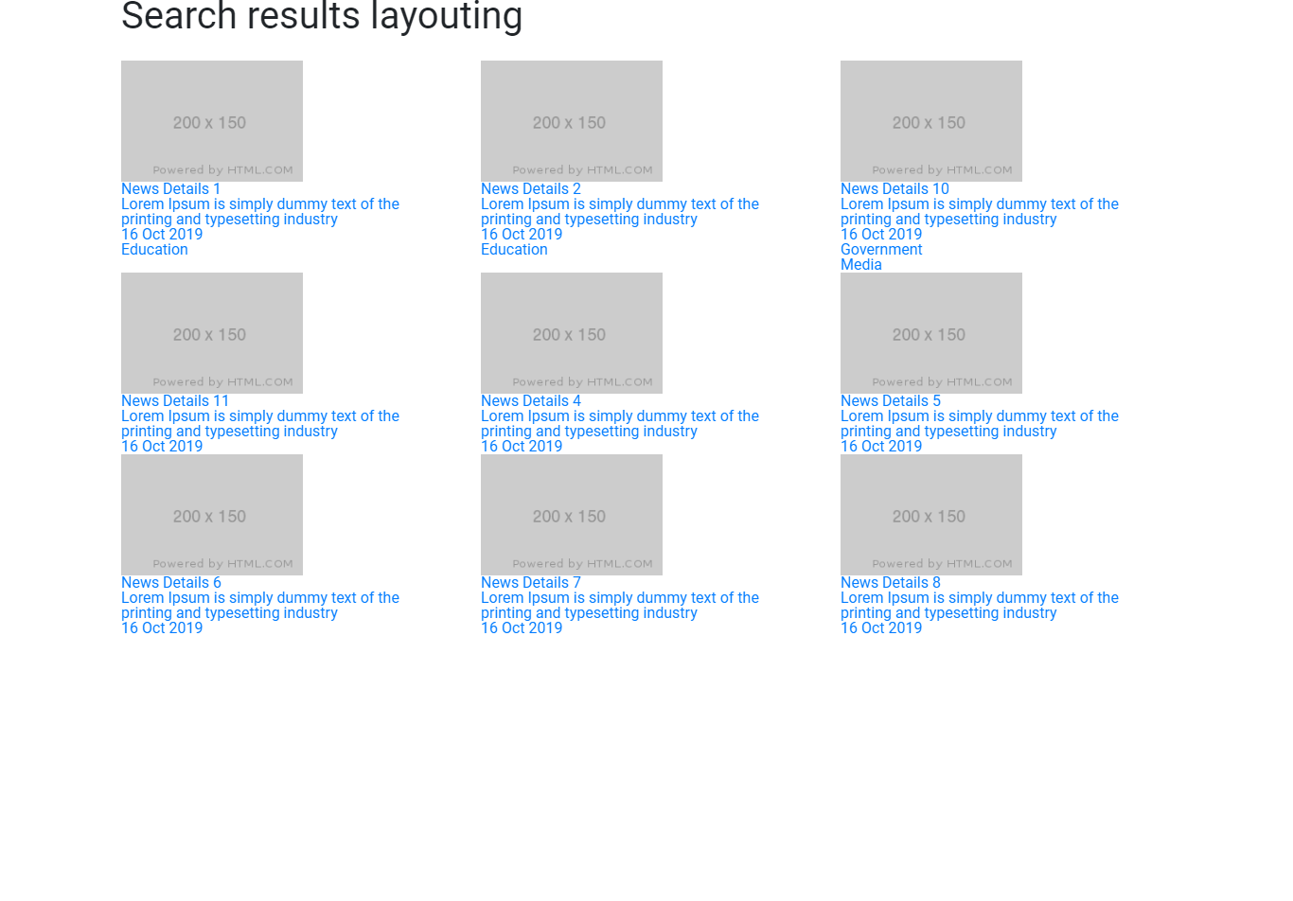

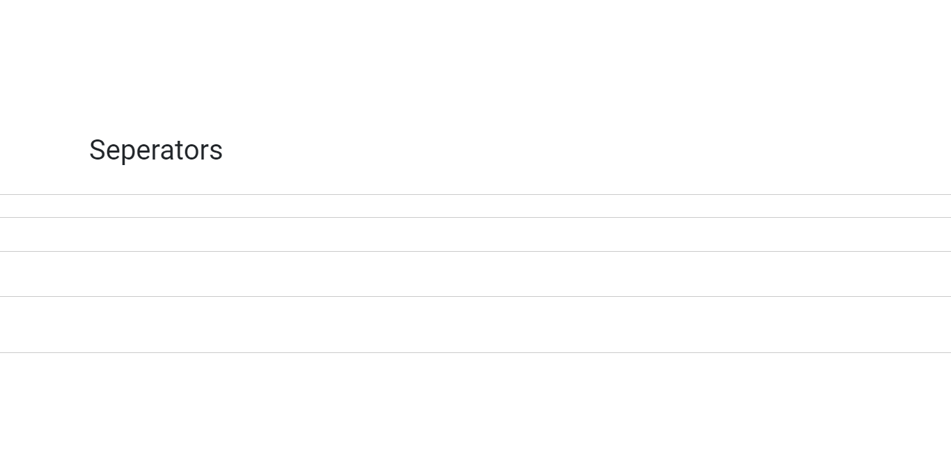

Call to Action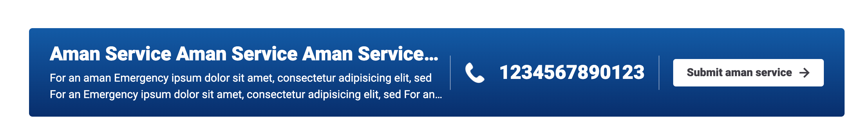

# How to use.

1. The available commands for this project .
   1. Compile : npm run gulp compile -- –path ex-layout –extension
   2. Compile & include under ADGE tenant : npm run gulp compile -- –path ex-layout –extension –full –dest [ADGEFolder]
   3. Deploy : npm run gulp deploy -- –path ex-layout –extension
2. *Now project have full copy from this extension theme under the project theme and you can apply the project brand guideline and configure component based on project needs.*

# Component features and configure.

You have access now to configure component with the below item.

**Buttons Styles**

$layout-button-hover-color : $white-color !default;

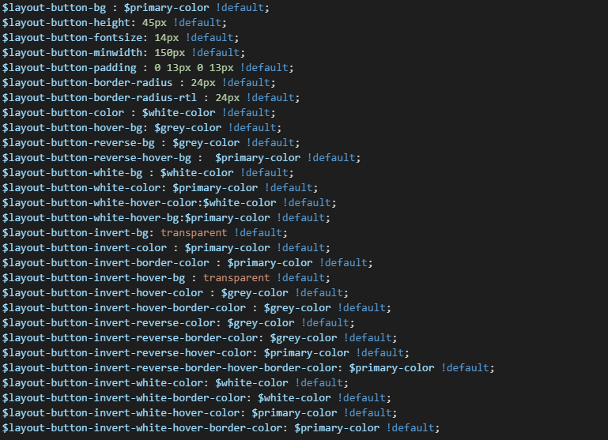

**Scrollbar colors**

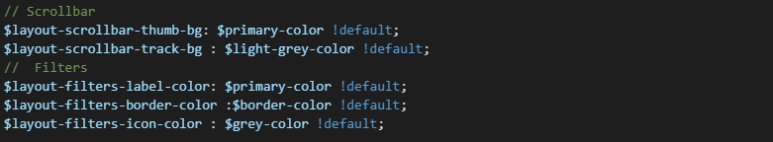

**Inputs colors**

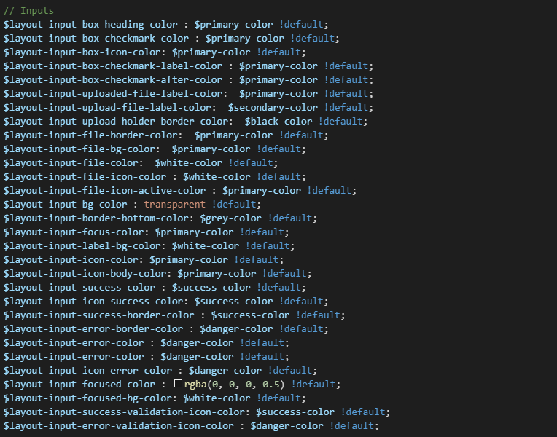

Headings options (Replace h2 with any of **h1,h3,h4,h5,h6,label,p,caption**)

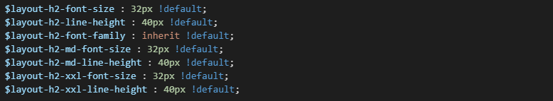

**Title options / hr colSupported fonts :**

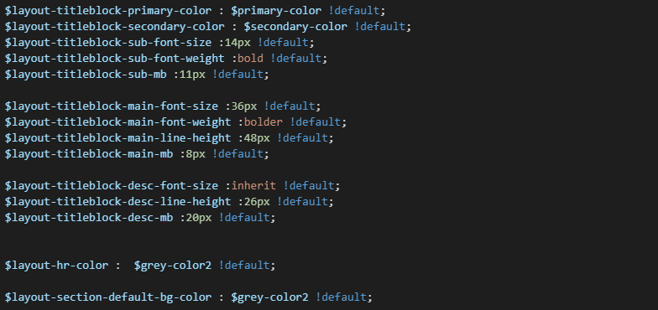

**Carousels default colors, layout utilities and font exts.**

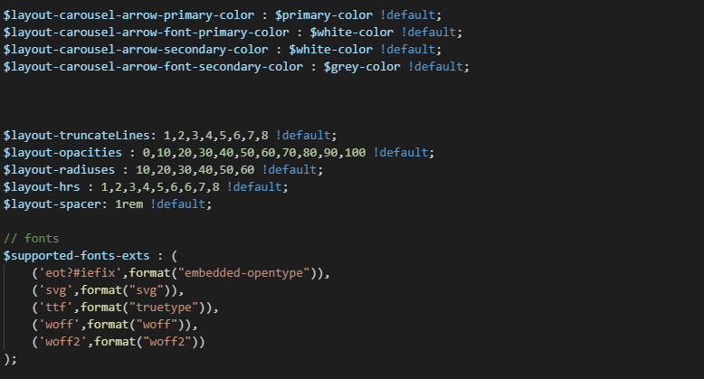

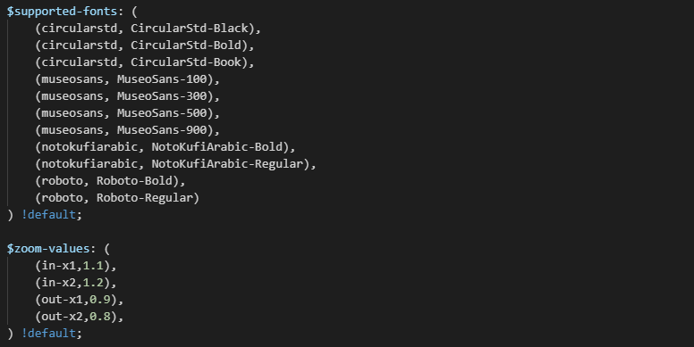

Call to Action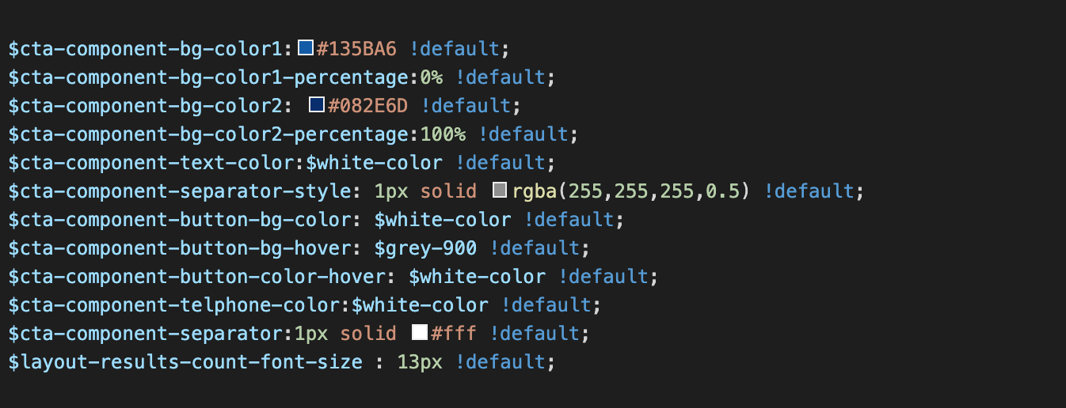

# Modifiers

1. **Accessibility**

This section has two modifiers (css classes)

* high-contrast – only add this class to the body
  + high-contrast--forced : to force high contrast in specific element
  + high-contrast--reset : to grayscale images if needed
* Zoom – this modifier has 4 values you can override **$zoom-values** and add your extra values

1. **Buttons** 
   1. To use buttons from layout use class **.button**
   2. Buttons has many modifiers
      1. button—icononly ( display only icon and ignore text)
      2. button—withouticon (display only text and hide icon)
      3. button—sharp ( disable border radius )
      4. button—uppercase ( Make all letters uppercased)
      5. button—white (Create button color to be white)
      6. button—reverse (Reverse button colors )
      7. button—invert (Invert colors ), you can use invert modifier with reverse/white effect
      8. button—borderless (Create button without border) \
      9. button—large ( reset button min width to be 200px )
      10. button—sitecore (Handle sitecore link)
2. **Fonts** 
   1. To add more fonts please override **$supported-fonts (folername,fontfamily)**
3. **Headings**
   1. Create title block use wrapper class (.title-block)
      1. Subtitle class is title-block__sub
      2. Main title class is title-block__main
      3. Description class is title-block__desc
      4. **Modifiers** : white color (title-block--white) , primary color (title-block--primary) , secondary colored (title-block--secondary).
4. **Helpers (Layout utilities )** 
   1. **Truncate** : use css class .**truncate** along with .**truncate-{#number}** to specify lines. You can override **$layout-truncateLines** to add more values, **supported lines 1-8.**
   2. **Opacity :** use **.opacity-{#numb}** to create opacity. **Supported values : 0,10,20,30,40,50,60,70,80,90,100.**
   3. **Rounded :** Border radius utility **.rounded-{#numb}.** Supported values : 10,20,30,40,50,60.
5. **Reset :** This file resting the default behavior for HTML tags.

# How to configure component.

You need to copy all variable that’s you need to change from file _variables.scss under vars folder under the extension theme component, then past the copy variables in file _override.scss under vars folder under the project theme folder.

# Examples

Examples1:

I need to change text color.

I’ll copy the below variables from extension theme.

$component-text-color: $primary-color;

Then will paste the above variable in project folder theme in file _override.scss and change with any variable based on site needs.

$component-text-color: $secondary-color;

Examples2:

I need to the button shape from square to had a rounded corner.  
I’ll copy the below variables from extension theme.

$button-shape-square: $border-radius-value;

$border-radius-value: 0px;

Then will paste the a above variable in project folder theme in file _override.scss and change with any variable based on site needs.

$button-shape-square: $border-radius-value;

$border-radius-value: 20px;